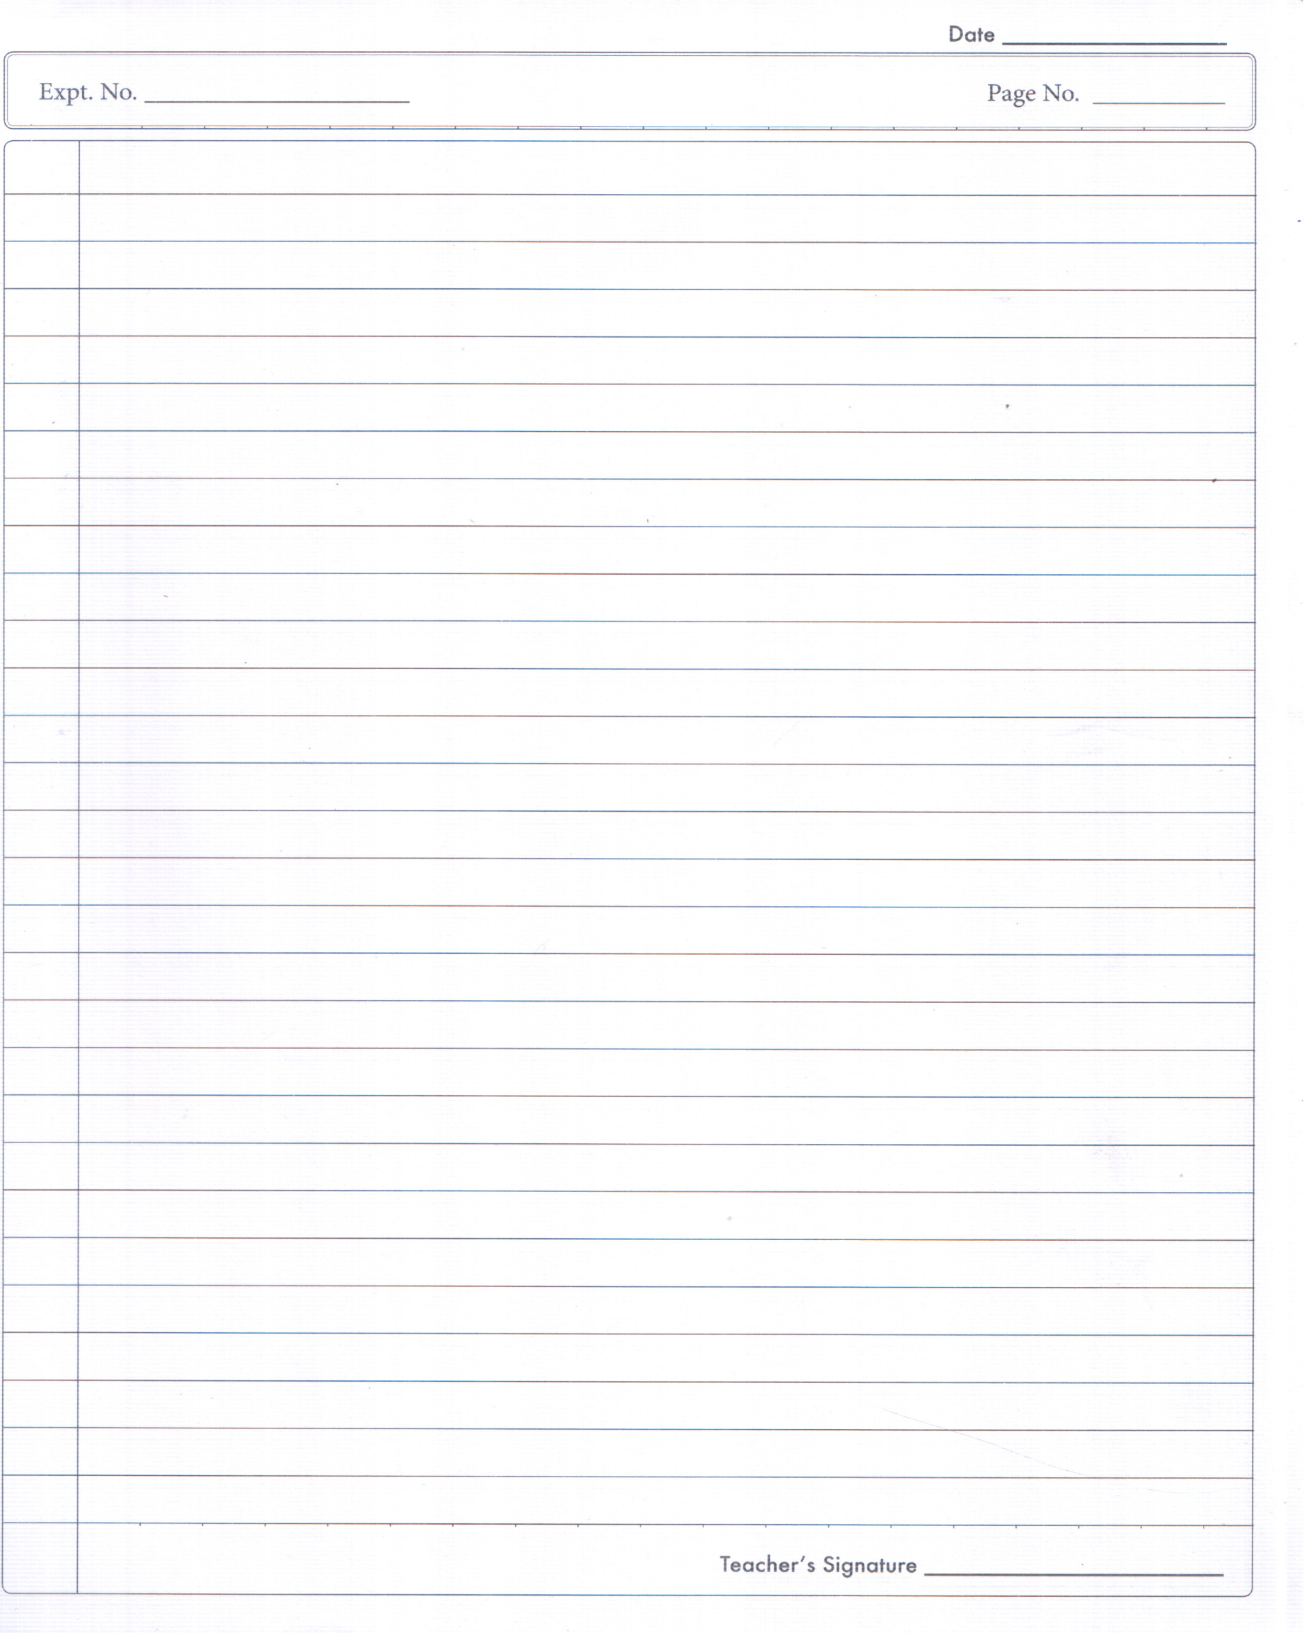
Aim of Experiment
Additive Manufacturing refers to a process by which digital 3D design data is used to build up a component in layers by depositing material. The term "3D printing" is increasingly used as a synonym for Additive Manufacturing. However, the latter is more accurate in that it describes a professional production technique which is clearly distinguished from conventional methods of material removal. Instead of milling a workpiece from solid block, for example, Additive Manufacturing builds up components layer by layer using materials which are available in fine powder form or in wire form. A range of different metals, plastics and composite materials may be used.
The technology has especially been applied in conjunction with Rapid Prototyping the construction of illustrative and functional prototypes. Additive Manufacturing is now being used increasingly in Series Production. It gives Original Equipment Manufacturers (OEMs) in the most varied sectors of industry the opportunity to create a distinctive profile for themselves based on new customer benefits, cost-saving potential and the ability to meet sustainability goals.

Types of 3D Printing Technologies
Different types of technology used for 3D printing like FDM, SLA, DLP, SLS, DMLS, SLM, EBM, Material Jetting, DOD, and Binder Jetting simply explained.

Fused Deposition Modelling (FDM)
Material Extrusion devices are the most commonly available — and the cheapest types of 3D printing technology in the world. You might be familiar with them as Fused Deposition Modelling, or FDM. They are also sometimes referred to as Fused Filament Fabrication, or FFF.
The way it works is that a spool of filament is loaded into the 3D printer and fed through to a printer nozzle in the extrusion head. The printer nozzle is heated to a desired temperature, whereupon a motor pushes the filament through the heated nozzle, causing it to melt.
The printer then moves the extrusion head along specified coordinates, laying down the molten material onto the build plate where it cools down and solidifies.
Once a layer is complete, the printer proceeds to lay down another layer. This process of printing cross-sections is repeated, building layer-upon-layer, until the object is fully formed. Depending on the geometry of the object, it is sometimes necessary to add support structures, for example if a model has steep overhanging parts.

Stereo-lithography (SLA)
SLA holds the historical distinction of being the world’s first 3D printing technology. Stereolithography was invented by Chuck Hull in 1986, who filed a patent on the technology and founded the company 3D Systems to commercialize it.
An SLA printer uses mirrors, known as galvanometers or galvos, with one positioned on the X-axis and another on the Y-axis. These galvos rapidly aim a laser beam across a vat of resin, selectively curing and solidifying a cross-section of the object inside this build area, building it up layer by layer.
Most SLA printers use a solid state laser to cure parts. The disadvantage to these types of 3D printing technology using a point laser is that it can take longer to trace the cross section of an object when compared to DLP.

Digital Light Processing (DLP)
Looking at Digital Light Processing machines, these types of 3D printing technology are almost the same as SLA. The key difference is that DLP uses a digital light projector to flash a single image of each layer all
at once (or multiple flashes for larger parts).
Because the projector is a digital screen, the image of each layer is composed of square pixels, resulting in a layer formed from small rectangular blocks called voxels.
DLP can achieve faster print times compared to SLA. That’s because an entire layer is exposed all at once, rather than tracing the cross-sectional area with the point of a laser.
Light is projected onto the resin using light-emitting diode (LED) screens or a UV light source (lamp) that is directed to the build surface by a Digital Micromirror Device (DMD).
A DMD is an array of micro-mirrors that control where light is projected and generate the light-pattern on the build surface.

Selective Laser Sintering (SLS)
Creating an object with Powder Bed Fusion technology and polymer powder is generally known as Selective Laser Sintering (SLS). As industrial patents expire, these types of 3D printing technology are becoming increasingly common and lower cost.
First, a bin of polymer powder is heated to a temperature just below the polymer’s melting point. Next, a recoating blade or wiper deposits a very thin layer of the powdered material — typically 0.1 mm thick — onto a build platform.
A CO2 laser beam then begins to scan the surface. The laser will selectively sinter the powder and solidify a cross-section of the object. Just like SLA, the laser is focused on to the correct location by a pair of galvos.
When the entire cross-section is scanned, the build platform will move down one layer thickness in height. The recoating blade deposits a fresh layer of powder on top of the recently scanned layer, and the laser will sinter the next cross-section of the object onto the previously solidified cross-sections.
These steps are repeated until all objects are fully manufactured. Powder which hasn’t been sintered remains in place to support the object that has, which eliminates the need for support structures.

Material Jetting (MJ)
Material Jetting (MJ) works in a similar way to a standard inkjet printer. The key difference is that, instead of printing a single layer of ink, multiple layers are built upon each other to create a solid part.

The print head jets hundreds of tiny droplets of photopolymer and then cures/solidifies them using an ultraviolet (UV) light. After one layer has been deposited and cured, the build platform is lowered down one layer thickness and the process is repeated to build up a 3D object.
MJ is different from other types of 3D printing technology that deposit, sinter or cure build material using point-wise deposition. Instead of using a single point to follow a path which outlines the cross-sectional area of a layer, MJ machines deposit build material in a rapid, line-wise fashion.
The advantage of line-wise deposition is that MJ printers are able to fabricate multiple objects in a single line with no impact on build speed. So long as models are correctly arranged, and the space within each build line is optimized, MJ is able to produce parts at a speedier pace than other types of 3D printer. Objects made with MJ require support, which are printed simultaneously during the build from a dissolvable material that’s removed during the post-processing stage. MJ is one of the only types of 3D printing technology to offer objects made from multi-material printing and full colour.

Drop on Demand (DOD)
Drop on Demand (DOD) is a type of 3D printing technology that uses a pair of ink jets. One deposits the build materials, which is typically a wax-like material. The second is used for dissolvable support material. As with
typical types of 3D printing technology, DOD printers follow a predetermined path to jet material in a point-wise deposition, creating the cross-sectional area of an object layer-by-layer.
DOD printers also use a fly-cutter that skims the build area after each layer is created, ensuring a perfectly flat surface before commencing the next layer. DOD printers are usually used to create patterns suitable for lost-wax casting or investment casting, and other mould-making applications.

Sand Binder Jetting
With Sand Binder Jetting devices, these are low-cost types of 3D printing technology for producing parts from sand, e.g. sandstone or gypsum.
For full colour models, objects are fabricated using a plaster-based or PMMA powder in conjunction with a liquid binding agent. The printhead first jets the binding agent, while a secondary print head jets in colour, allowing full colour models to be printed.
Once parts have fully cured they are removed from the loose unbonded powder and cleaned. To enhance mechanical properties, parts are often exposed to an infiltrant material.
There are a large number of infiltrants available, each resulting in different properties. Coatings can also be added to improve the vibrancy of colors.
Binder Jetting is also useful for the production of sand cast moulds and cores. The cores and moulds are generally printed with sand, although artificial sand (silica) can be used for special applications.
After printing, the cores and mouldss are removed from the build area and cleaned to remove any loose sand. The moulds are typically immediately ready for casting. After casting, the mould is broken apart and the final metal component removed.
The big advantage of producing sand casting cores and moulds with Binder Jetting is the large, complex geometries the process is able to produce at relatively low-cost. Plus, the process is quite easy to integrate into existing manufacturing or foundry process without disruption.

Metal Binder Jetting
Binder Jetting can also be used for the fabrication of metal objects. Metal powder is bound using a polymer binding agent. Producing metal objects using Binder Jetting allows for the production of complex geometries well beyond the capabilities of conventional manufacturing techniques.
Functional metal objects can only be produced via a secondary process like infiltration or sintering, however. The cost and quality of the end result generally defines which secondary process is the most appropriate for a certain application. Without these additional steps, a part made with metal Binder Jetting will have poor mechanical properties.
The infiltration secondary process works as follows: initially metal powder particles are bound together using a binding agent to form a “green state” object. Once the objects have fully cured, they are removed from the loose powder and placed in a furnace, where the binder is burnt out. This leaves the object at around 60 percent density with voids throughout.
Next, bronze is used to infiltrate the voids via capillary action, resulting in an object with around 90 percent density and greater strength. However, objects made with metal Binder Jetting generally have lower mechanical properties than metal parts made with Powder Bed Fusion.
The sintering secondary process can be applied where metal parts are made without infiltration. After printing is complete, green state objects are cured in an oven. Next, they’re sintered in a furnace to a high density of around 97 percent. However, non-uniform shrinkage can be an issue during sintering and should be accounted for at the design stage.

Direct Metal Laser Sintering (DMLS) / Selective Laser Melting (SLM)
Both Direct Metal Laser Sintering (DMLS) and Selective Laser Melting (SLM) produce objects in a similar fashion to SLS. The main difference is that these types of 3D printing technology are applied to the production of metal parts.
DMLS does not melt the powder but instead heats it to a point so that it can fuse together on a molecular level. SLM uses the laser to achieve a full melt of the metal powder forming a homogeneous part. This results in a part that has a single melting temperature (something not produced with an alloy).
This is the main difference between DMLS and SLM; the former produces parts from metal alloys, while the latter form single element materials, such as titanium.
Unlike SLS, the DMLS and SLM processes require structural support, in order to limit the possibility of any distortion that may occur (despite the fact that the surrounding powder provides physical support).
DMLS/SLM parts are at risk of warping due to the residual stresses produced during printing, because of the high temperatures. Parts are also typically heat-treated after printing, while still attached to the build plate, to relieve any stresses in the parts after printing.

Electron Beam Melting (EBM)
Distinct from other Powder Bed Fusion techniques, Electron Beam Melting (EBM) uses a high energy beam, or electrons, to induce fusion between the particles of metal powder. A focused electron beam scans across a thin layer of powder, causing localized melting and solidification over a specific cross-sectional area. These areas are built up to create a solid object.
Compared to SLM and DMLS types of 3D printing technology, EBM generally has a superior build speed because of its higher energy density. However, things like minimum feature size, powder particle size, layer thickness and surface finish are typically larger.
Also important to note is that EBM parts are fabricated in a vacuum, and the process can only be used with conductive materials.

Advantages
The strengths of Additive Manufacturing lie in those areas where conventional manufacturing reaches its limitations. The technology is of interest where a new approach to design and manufacturing is required so as to come up with solutions. It enables a design-driven manufacturing process - where design determines production and not the other way around. What is more, Additive Manufacturing allows for highly complex structures which can still be extremely light and stable. It provides a high degree of design freedom, the optimization and integration of functional features, the manufacture of small batch sizes at reasonable unit costs and a high degree of product customization even in serial production.
Fused Deposition Modelling (FDM), or Fused Filament Fabrication (FFF), is an additive manufacturing process that belongs to the material extrusion family. In FDM, an object is built by selectively depositing melted material in a pre-determined path layer-by-layer. The materials used are thermoplastic polymers and come in a filament form.
FDM is the most widely used 3D Printing technology: it represents the largest installed base of 3D printers globally and is often the first technology people are exposed to. In this article, the basic principles and the key aspects of the technology are presented.
A designer should keep in mind the capabilities and limitations of the technology when fabricating a part with FDM, as this will help him achieve the best result.

Printer Parameters
What is important from a designer's perspective is build size and layer height:
The available build size of a desktop 3D printer is commonly 250 x 250 x 250 mm, while for industrial machines this can be as big as 1000 x 1000 x 1000 mm. If a desktop machine is preferred (for example for reducing the cost) a big model can be broken into smaller parts and then assembled.
The typical layer height used in FDM varies between 50 and 400 microns and can be determined upon placing an order. A smaller layer height produces smoother parts and captures curved geometries more accurately, while a larger height produces parts faster and at a lower cost. A layer height of 250 microns is used in our StratasysFortus 400 MC.

Operation Procedure of FDM based 3D printer
1. Design of a solid model using 3d designing software i.e. SolidWorks, Catia, Unigraphics, Pro Engineer etc.
2. Save the file as STL format, because 3D printers software are recognize only STL format.
3. To create the path for layer to build the job in Fortus 400 MC use a software called Insight. In which several options are given for building of job. After processing in Insight software another software is used to define the build area to define the place, where the product will be printed.
4. A spool of thermoplastic filament is first loaded into the printer. Once the nozzle has reached the desired temperature, the filament is fed to the extrusion head and in the nozzle where it melts.
5. The extrusion head is attached to a 3-axis system that allows it to move in the X, Y and Z directions. The melted material is extruded in thin strands and is deposited layer-by-layer in predetermined locations, where it cools and solidifies. Sometimes the cooling of the material is accelerated through the use of cooling fans attached on the extrusion head.
6. After completion of printing process, remove the part from machine & remove support material from the part by hand tools/ dissolving process.

Safety Precaution for 3D Printing
(a) Do not operate 3D printer without training in the correct and safe operation of the 3D printer.
(b) Use 3D printers in a well-ventilated area.
(c) Do not open 3D printer covers once a print job is underway.
(d) Equip the facility with Class D fire extinguishers and train on proper use.
(e) Wear a protective P100 respirator dust mask when accessing the printer stage area
(f) Removing of support material processes that use an alkaline bath to dissolve support material, Wear eye protection around liquid materials that can splash.
(g) Keep model and support materials away from areas where food and drink is stored, prepared, or consumed.
(h) Always cutoff main power supply from the main switch when doing any maintenance or intervention on the machine.
(i) 3D printers contains a lot of moving mechanical parts, at the time of machine running do not put hand inside of machine.
(j) Always make sure the heating elements are cold before starting any maintenance or modifications on your machine.

